**NAH Pilot Oracle and Custom developed components used in E-ARK Pilot 7**

***E-ARK Pilot 7 Tools Presentation***

**Version 1.2 – October 31, 2016**

Main Editor:

* György Csaba Kovács (XperTeam Ltd.)

Other Contributors:

|  |  |  |
| --- | --- | --- |
| **Change Log** | | |
| **Date** | **Editor** | **Comments** |
| 30/08-16 | György Csaba Kovács | First version |
| 26/09-16 | György Csaba Kovács | Updated version |
| 31/10-16 | György Csaba Kovács | Updated version |
|  |  |  |
|  |  |  |
|  |  |  |
|  |  |  |
|  |  |  |
|  |  |  |

Table of Contents

1. Introduction 1

1.1 Audience 1

1.2 Scope of pilot 1

2. Tools used in Pilot 7 1

2.1 Hardware specification 2

2.2 Oracle Server side components 2

2.3 Oracle Client components 3

3. Scenarios 3

3.1 Archival Process Steps 3

3.1.1 Data Access Steps 4

3.1.2 The Data Warehouse Concept 5

3.1.3 Querying Relational Database 6

3.1.4 Moving data closer to requester analytical needs 7

4. Oracle components 8

4.1 Oracle Database 8

4.2 Oracle Weblogic Server 8

4.3 Oracle Data Integrator 8

4.3.1 Data transformation 9

4.3.2 Data load 10

4.4 Oracle Analytic Workspace Manager 11

4.5 Oracle Business Intelligence 11

4.5.1 BI model 11

4.5.2 Data Access with BI 11

4.5.3 BI Catalog 11

4.5.4 BI Dashboards and Analysis 12

4.5.5 Custom Analysis created with BI 13

4.5.5.1 Distribution of criminal cases over age group and gender 13

4.5.5.2 Criminal cases on map 14

4.5.5.3 Heat map 15

4.5.5.4 Interactive charts 16

4.6 Oracle Rest Data Services 17

4.7 Oracle Application Express 17

4.7.1 Data Explorer 17

List of figures

1. Archival process steps 4

2. Archived data access flow 5

3. Data warehouse layers 6

4. Archived data model 7

5. Business Intelligence model 8

6. ODI Studio Design pane 9

7. ODI Mapping 10

8. Data Integrator process flow 10

9. BI Administration Tool 11

10. BI Catalog 12

11. BI Dashboard 13

12. Distribution of criminal cases 14

13. Criminal cases on map 15

14. Heat map 16

15. Interactive charts 16

16. Data Explorer pivot report 18

# Introduction

In E-ARK Project Pilot 7, the Oracle components was used in “archived database access” scenarios.

Achievements/solution using Data Warehouse approach in E-ARK Pilot 7

E-ARK WEB - Data Exploration Solution

Data Warehouse concept & components usage in E-ARK WEB - Data Exploration

E-ARK Oracle tools in database preservation and access   
(Oracle APEX, ODI, BI)

## Audience

This documents gives a brief introduction for end-users, how to use the installed Oracle and custom software components used in E-ARK Project Pilot 7.

## Scope of pilot

T2.5.7 Full scale pilot no. 7. – Access to databases

NAH will extract structured content from an Oracle database with the tools developed by WP3. The pilot will examine the applicability of data-warehouse concepts in an archival environment in order to maintain both the original structure and intellectual interpretability of ingested data. The working prototype for access will be a user-friendly web-based application based on the DIP specification of WP5.

* **Scope:** Representation of not less than 2 databases of different sizes and complexities with restricted and open content.
* **Objects:** Extract data from the EDRMS and the databases, create SIPs for structured and unstructured records using the ESSArch Tools, ingest the SIPs to the repository using the ESSArch Preservation Platform, for further evaluation.
* **Participants:** National Archives of Hungary (digital archives), data provider
* **Data owner:** Prosecution Service of Hungary
* **Platform:** DBExport Tool, Oracle APEX, development in Java

Extract data from a relational database (SIARD 2.0)

Create submission information package (SIP)

Ingest package into a long term archive repository (SIP to AIP)

Examine the applicability of data warehouse concepts in an archival environment

Create user friendly web-based application on the DIP specification

# Tools used in Pilot 7

* Database Preservation Toolkit (DBPTK)
* Repository of Authentic Digital Objects SIP creator (RODA-in)
* E-ARK WEB (Hadoop, HBASE, SolR, Lily)
* Oracle Database Enterprise Edition with OLAP option
* Oracle Data Integrator
* Oracle SQL Developer
* Oracle Analytic Workspace Manager
* Oracle Application Express
* Oracle Business Intelligence
* Oracle Maps Viewer

## Hardware specification

The server side software components was installed into the NAH’s hardware infrastructure. The hardware and OS environment settings of the installed machine:

|  |  |
| --- | --- |
| **Hardware/OS** | **Settings** |
| SLOT | 12 |
| BLADE TYPE | HS23 (Type 7875) |
| CPU | 2x Intel® Xeon™ CPU E5-2660 |
| MEMORY | 48 GB |
| DISK | 2x 300GB SAS |
| OS | Redhat 6.2 |
| HOSTNAME | hadoop-5 |
| LOCAL IP | 10.20.77.5 |

The client software components was installed into a notebook machine. The hardware and OS environment settings of the installed machine:

|  |  |
| --- | --- |
| **Hardware/OS** | **Settings** |
| CPU | CPU: Intel® Core™ i7-4720HQ CPU @ 2.60GHz |
| MEMORY | 16 GB |
| DISK | 500 GB |
| OS | Windows 10 64bit |

## Oracle Server side components

Installed Oracle server side software components:

|  |  |  |
| --- | --- | --- |
| **Software name** | **Version** | **Remarks** |
| Oracle Database | 12.1.0 | Enterprise Edition with OLAP option |
| Oracle Weblogic Server | 12.2.1 | Fusion Middleware Infrastructure |
| Oracle Business Intelligence | 12.2.1 | BI Enterprise Edition. Used components: Answers and Dashboards |
| Oracle Data Integrator | 12.2.1 | Repository installed into Oracle Database |
| Oracle Rest Data Services | 3.0.4 | Required to handle APEX requests |
| Oracle Application Express | 5.0.3 | Repository installed into Oracle Database |

## Oracle Client components

Installed Oracle client software components:

|  |  |  |
| --- | --- | --- |
| **Software name** | **Version** | **Remarks** |
| Oracle SQL Developer | 4.1.1 | Required to access the Oracle Database objects |
| Oracle Data Integrator Studio | 12.2.1 | Required to create source to target mappings and process flows |
| Oracle BI Administration Tool | 12.2.1 | Required to create BI model |
| Oracle Analytic Workspace Manager | 12.1.0 | Required to create OLAP cubes |

# Scenarios

Pilot 7 defines five scenarios:

|  |  |
| --- | --- |
| **Scenario** | **Settings** |
| Scenario 1 | SIP Creation and Ingest of old (not normalized) database in SIARD 2.0 format |
| Scenario 2 | SIP Creation and Ingest of unstructured files |
| Scenario 3 | Extract SIARD Package from Preservica/E-ARK AIP (APEX/Oracle BI access) |
| Scenario 4 | Search and present SIARD based information with E-ARK access tools (HADOOP based search and access with HIVE Presentation in local environment) |
| Scenario 5 | Access information from unstructured files (Access PDF documents and image files with EAD metadata as Preservica/E-ARK DIP) |

## Archival Process Steps

* Extract data from a relational database into SIARD format (XML) using DBPTK
* Create SIP (pack the SIARD file and add extra meta data) with RODA-in
* Ingest the SIP and convert to AIP into the long term archive repository with E-ARK WEB
* Index the archive with EARK WEB to enable full text search

Example of Archival Process

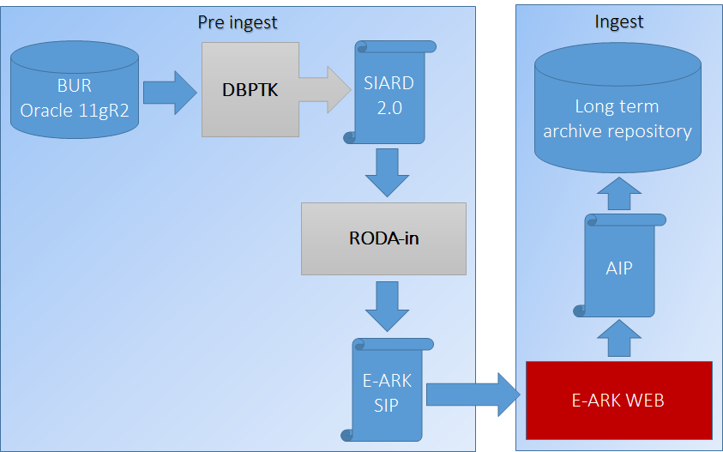

1. Archival process steps

* Extract data from a relational database into SIARD format (XML) using DBPTK
* Create SIP (pack the SIARD file and add extra meta data) with RODA-in
* Ingest the SIP and convert to AIP into the long term archive repository with E-ARK WEB
* Index the archive with EARK WEB to enable full text search

### Data Access Steps

* Search the repository and create from AIPs the DIP with EARK WEB
* Load the DIP into live database (for example Oracle) with DBPTK
* Create new data model (using data warehouse concepts) with SQL Developer to represent the data in a meaningful format
* Load and transform the data with Oracle Data Integrator into the new data model
* Optionally create multidimensional model, to pre-aggregate data (OLAP)
* Create Business Model for Oracle Business Intelligence (identify fact and dimensions, join tables, create measures and hierarchies, add meaningful names to tables and columns, etc.)
* Load the business model into BI Catalog
* Create reports, analysis, charts in Oracle BI and Oracle APEX Data Explorer
* Grant access on the reports and analysis to the requester

Archived Data Access

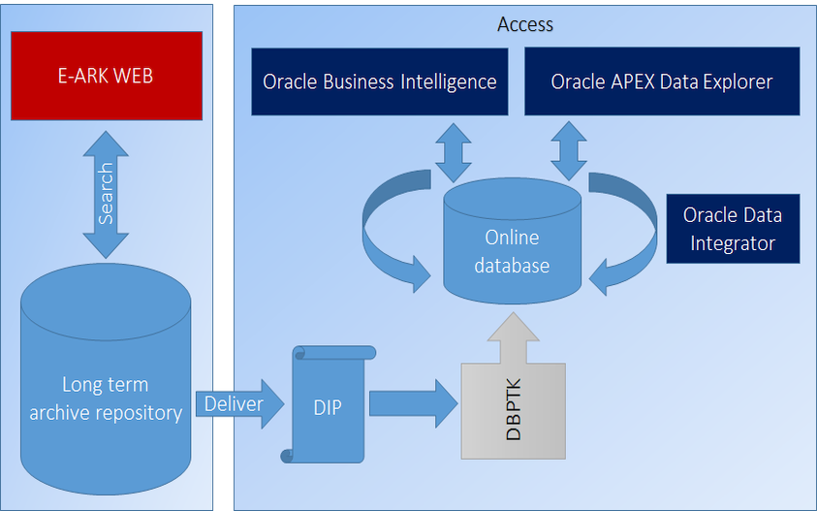

2. Archived data access flow

### The Data Warehouse Concept

We examined the applicability of data warehouse concept in Pilot 7, because some characteristics of a data warehouse can solve complex problems, which an archivist/consumer will face, when an archived database content must be accessed and analysed. These characteristics are the following:

* Data from multiple data sources can be converted, transformed and ingested into a centralized database
* Tables can be de-normalized, no complex joins needed when querying data
* The database structure is hidden by the business model, when analysing the data, the archivist/consumer only must know the „business term” not the structure of the database
* Powerful analytic tools exists, capable to integrate, analyse and visualize the data from various sources

The layers of a data warehouse contains the source data in different stages.

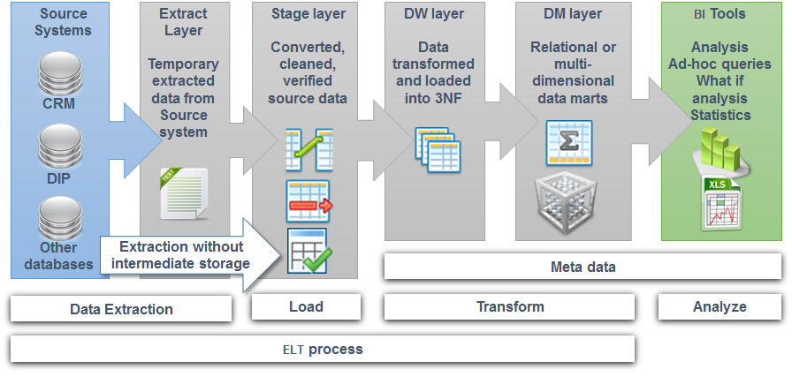

3. Data warehouse layers

In our pilot we loaded the data with DBPTK directly into DW Layer. The DM Layer was populated from DW, with custom developed mappings using ODI.

### Querying Relational Database

Problems when querying data from normalized relational database:

Multiple table must be joined, even for simply data analysis

The table and column names holds the business information

If foreign keys missing, hard to identify the relation between the tables

Complex queries can be slow

The archivist must know the database structure

Archived Database Data Model

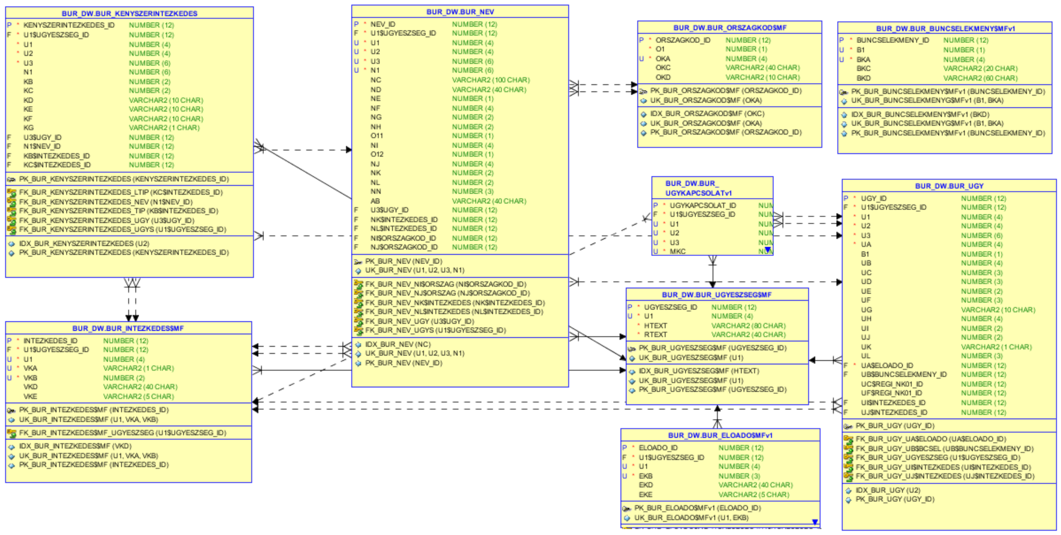

4. Archived data model

### Moving data closer to requester analytical needs

In order to fulfil the analytical needs over a data set (in our case DIP), some data preparation (using data warehouse concepts) can help the requester to easily access the data and to better understand the meaning of the data:

* The data can be analysed more easily, when it is prepared, transformed and de-normalized
* Building data warehouse data marts can significantly simplify the original data model (less tables, less joins, meaningful attribute names)
* Load and transform the data with ODI
* Create business model (hides the complexity of the database)
* Pre-create reports, analysis and dashboards

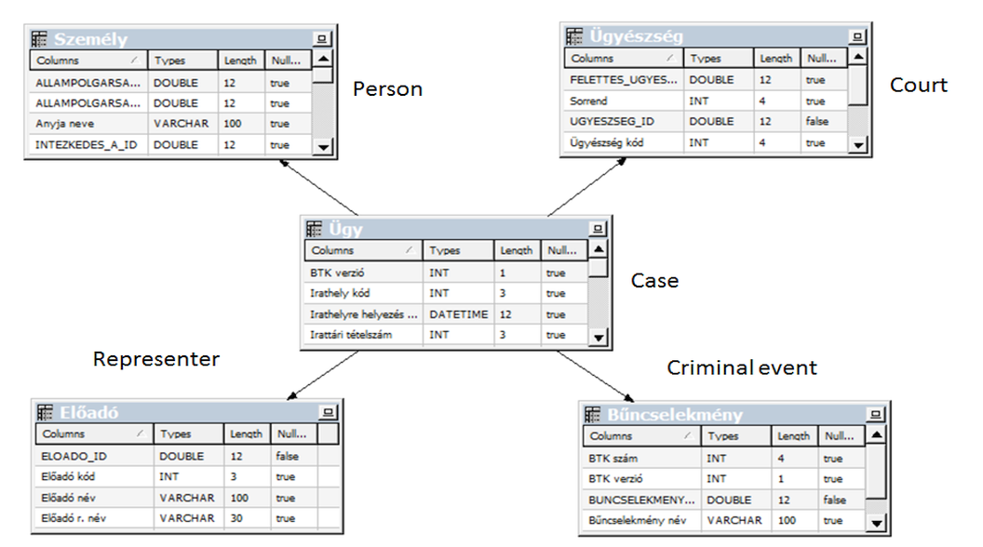

5. Business Intelligence model

# Oracle components

## Oracle Database

Oracle Database Online Documentation

https://docs.oracle.com/database/121/nav/portal_4.htm

## Oracle Weblogic Server

Oracle WebLogic Server Documentation

<https://docs.oracle.com/middleware/12211/wls/index.html>

## Oracle Data Integrator

Oracle Data Integrator (ODI) is a comprehensive data integration platform that covers all data integration requirements: from high-volume, high-performance batch loads, to event-driven integration processes, to SOA-enabled data services.

In a data warehouse environment it is a crucial step selecting the right integration tool. A well-designed data warehouse with a declarative integration tool can prepare and transform the data from many different data sources for any analytical needs. We decided to use ODI in E-ARK Project Pilot 7.

Some ODI features:

* declarative user interface
* flexible and high-performance architecture
* parallelism when executing data integration processes
* big data support

With ODI, you can create or reverse engine the source and target models, you can declaratively define mappings between source and targets and you can organize the mappings into process flows to load the data in a predefined order. All these functions can be accessed using ODI Studio, the visual metadata manager of the ODI Repository.

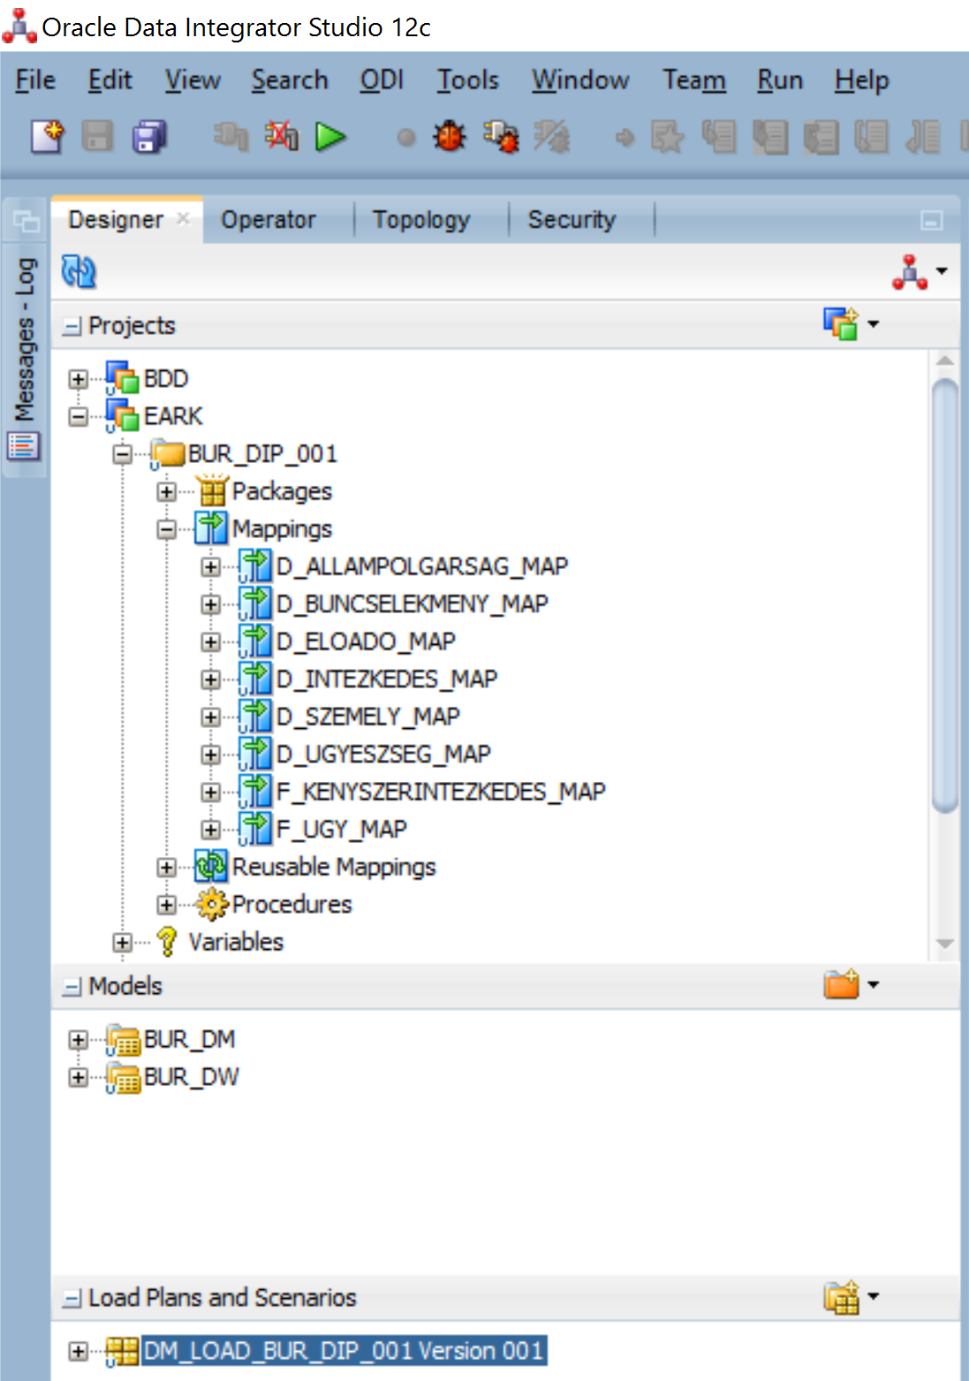

6. ODI Studio Design pane

More detailed documentation can be accessed from [Oracle Data Integrator Documentation](https://docs.oracle.com/middleware/12211/odi/index.html) web page.

### Data transformation

We used in E-ARK Project Pilot 7 the ODI tool, to transform and load the data from a DIP into data marts. The DIP content was and archived relational database owned by Prosecution Service of Hungary. The DIP content was loaded with DPTK into the BUR_DW Oracle database schema.

The two data marts contained 7 dimension and 2 fact tables. The data mart definition was stored in BUR_DM Oracle database schema. Each target table transformation rule (joins, filters, expressions, etc.) was visually designed and added to mappings using ODI Studio.

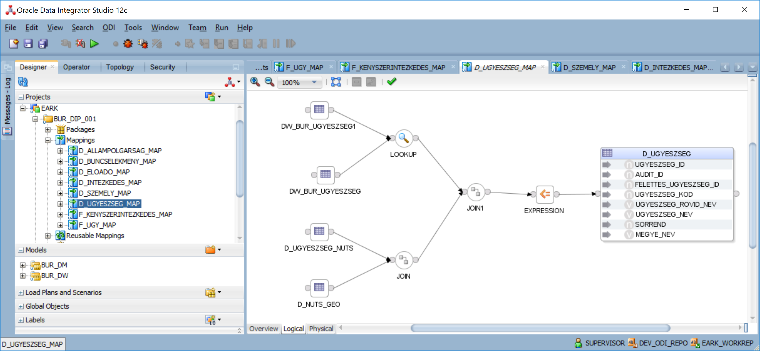

7. ODI Mapping

### Data load

The created mappings was incorporated into an ODI Package, called DM_LOAD_BUR_DIP_001. In the package was defined the execution order of the mappings. This is called in data warehouse terminology the “process flow”.

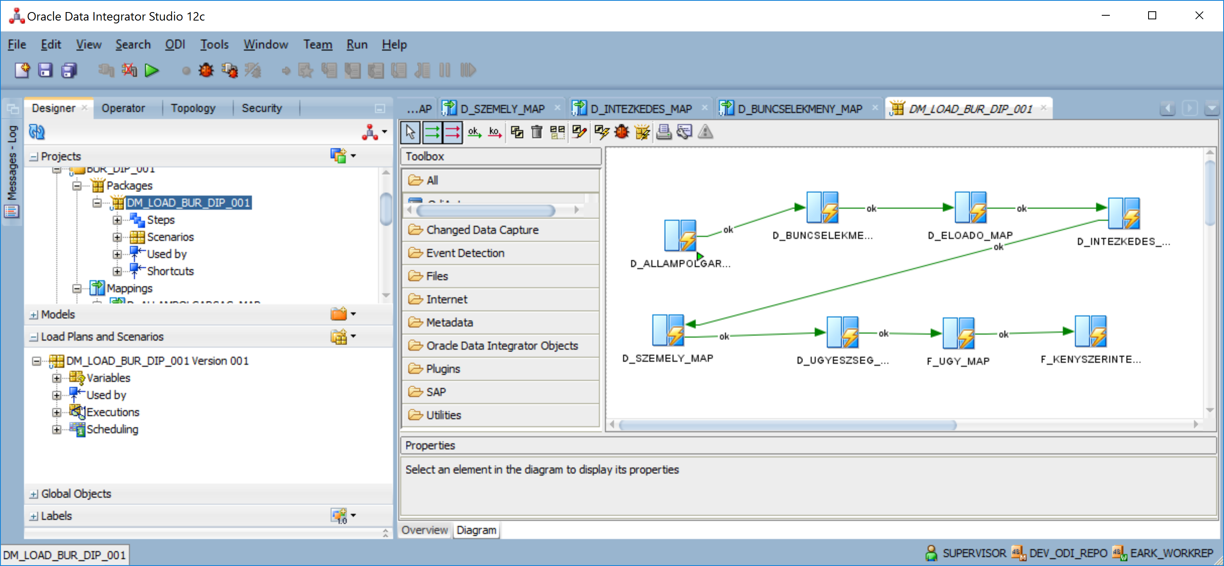

8. Data Integrator process flow

For the package a load plan was generated and executed with ODI Studio Operator module. With the execution of the process flow, all source data from DIP, was transformed and loaded into data marts dimensions and facts, ready to analyze the data.

## Oracle Analytic Workspace Manager

## Oracle Business Intelligence

Oracle Business Intelligence Enterprise Edition Documentation

<https://docs.oracle.com/middleware/12211/biee/index.html>

### BI model

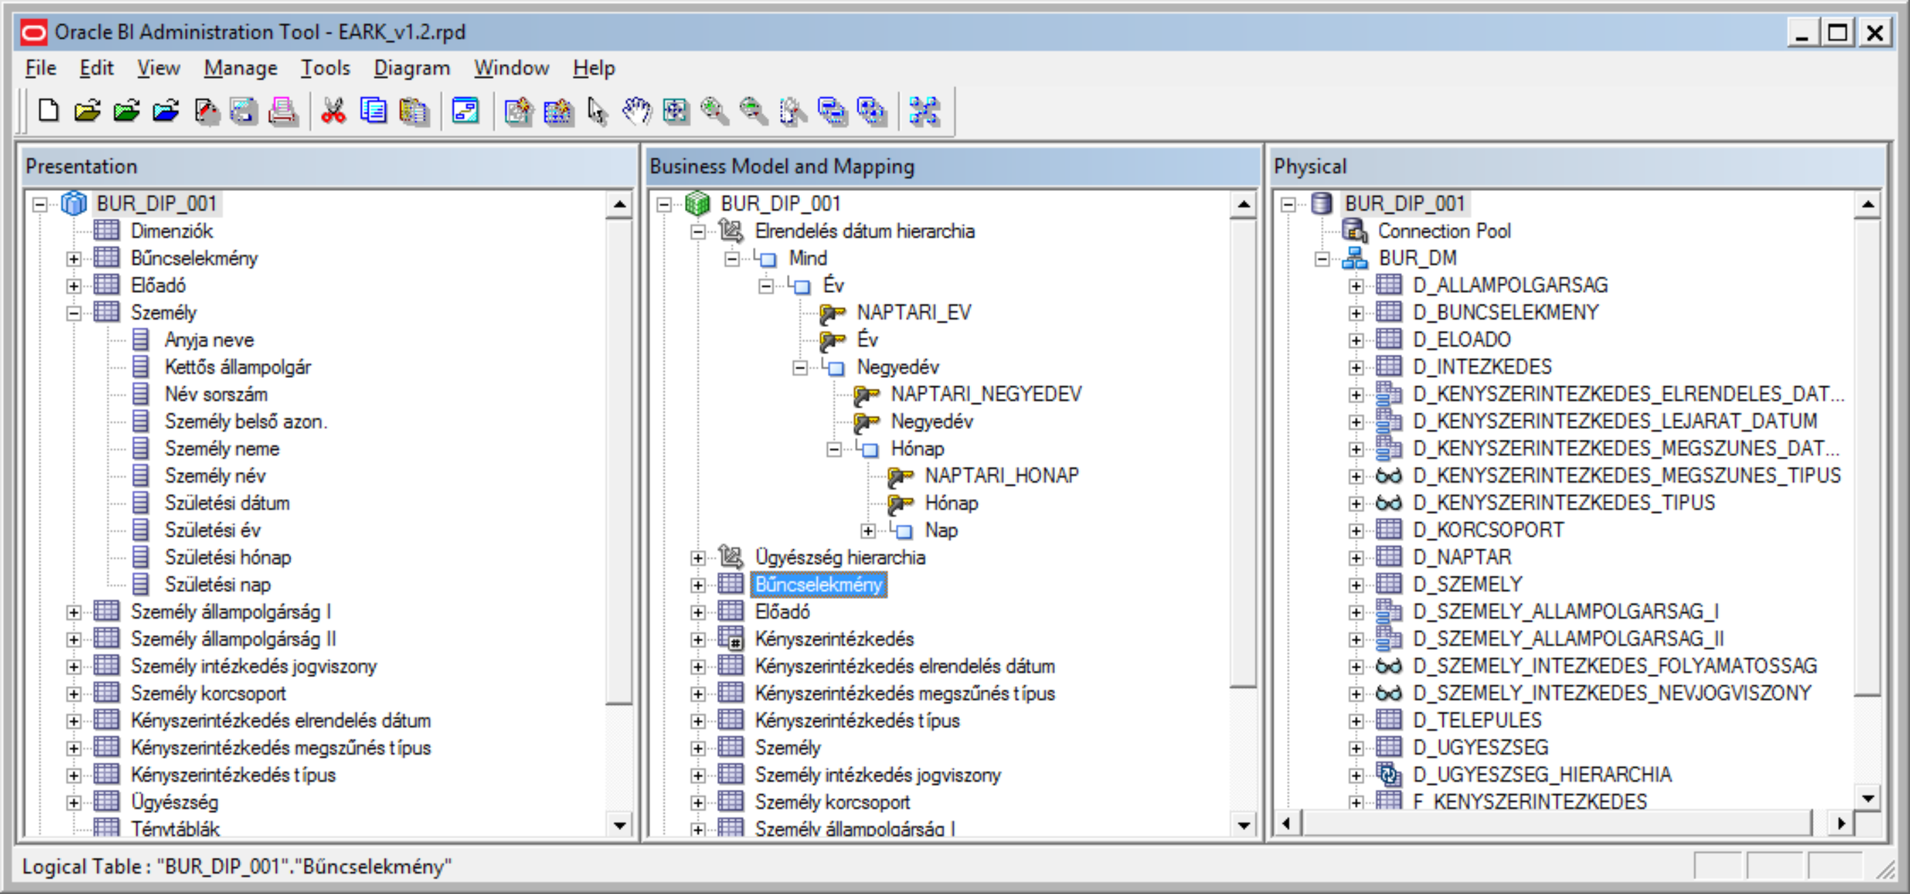

9. BI Administration Tool

### Data Access with BI

BI Analysis and Interactive Reporting

* catalog (BI objects repository)
* self-service, ad-hoc queries
* analysis, reports
* dashboards, dashboard prompts
* charts, maps
* drill down, hierarchy navigation
* built-in analytic functions
* data export into CSV, Excel

### BI Catalog

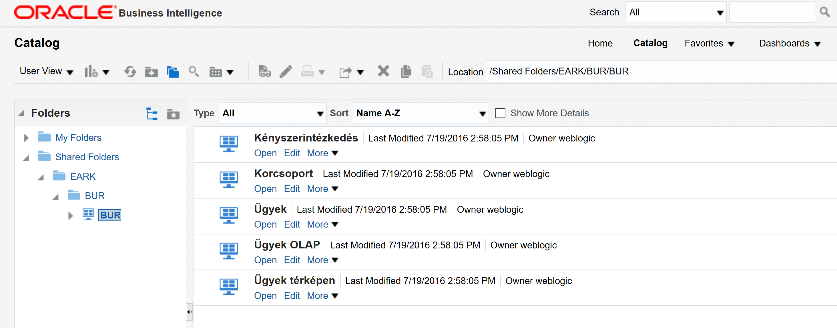

10. BI Catalog

### BI Dashboards and Analysis

In Pilot 7 we created BI Dashboards and predefined analysis for end users. A dashboard can have multiple pages, a page can contain prompts and one or more predefined analysis. Prompts are responsible to dynamically filter the data, analysis are responsible to visualize the data.

There are several visualization type, which can be used in Oracle BI analysis:

* tabular reports
* pivot reports
* charts (bar, stacked bar, pie, line, etc.)
* paretto chart
* heat maps
* trellis charts
* gauges
* map

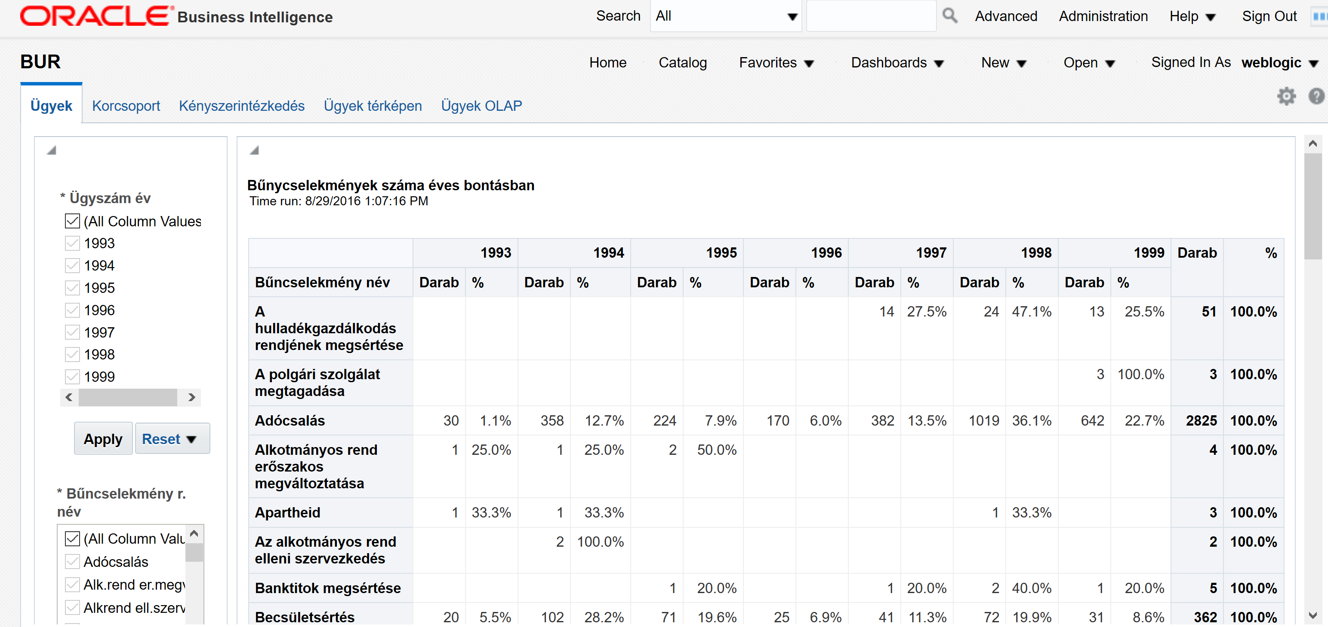

11. BI Dashboard

### Custom Analysis created with BI

The consumer or data requester can create custom BI analysis, if the predefined analysis are not fulfilling the data needs. Oracle BI provides an intuitive web based interface, to create ad-hoc analysis in a self-service manner. The analyst can choose from BI model subject areas, which defines what data sets can be used in the corresponding analysis.

Steps to create a new analysis:

* choose the subject area (typically a subject area contains facts, dimensions and hierarchies)
* choose the Presentation folder attributes (typically fact measures or dimension attributes)
* add filter conditions to attributes
* create custom calculations
* add different data visualizations to analysis (table reports, charts, maps, etc.)
* add conditional formatting to data columns, rows or cells
* define aggregations (sum, avg, min, max, count, etc.)
* define interactions (drill down, invoking another analysis)

In Pilot 7 we created some example analysis, to demonstrate how a data stored in a data warehouse can be analysed and visualized. In the following chapters we will give a brief

#### Distribution of criminal cases over age group and gender

This analysis shows the distribution of the number of criminal cases over age group and gender using two type of visualization: pivot table and horizontal stacked bar chart.

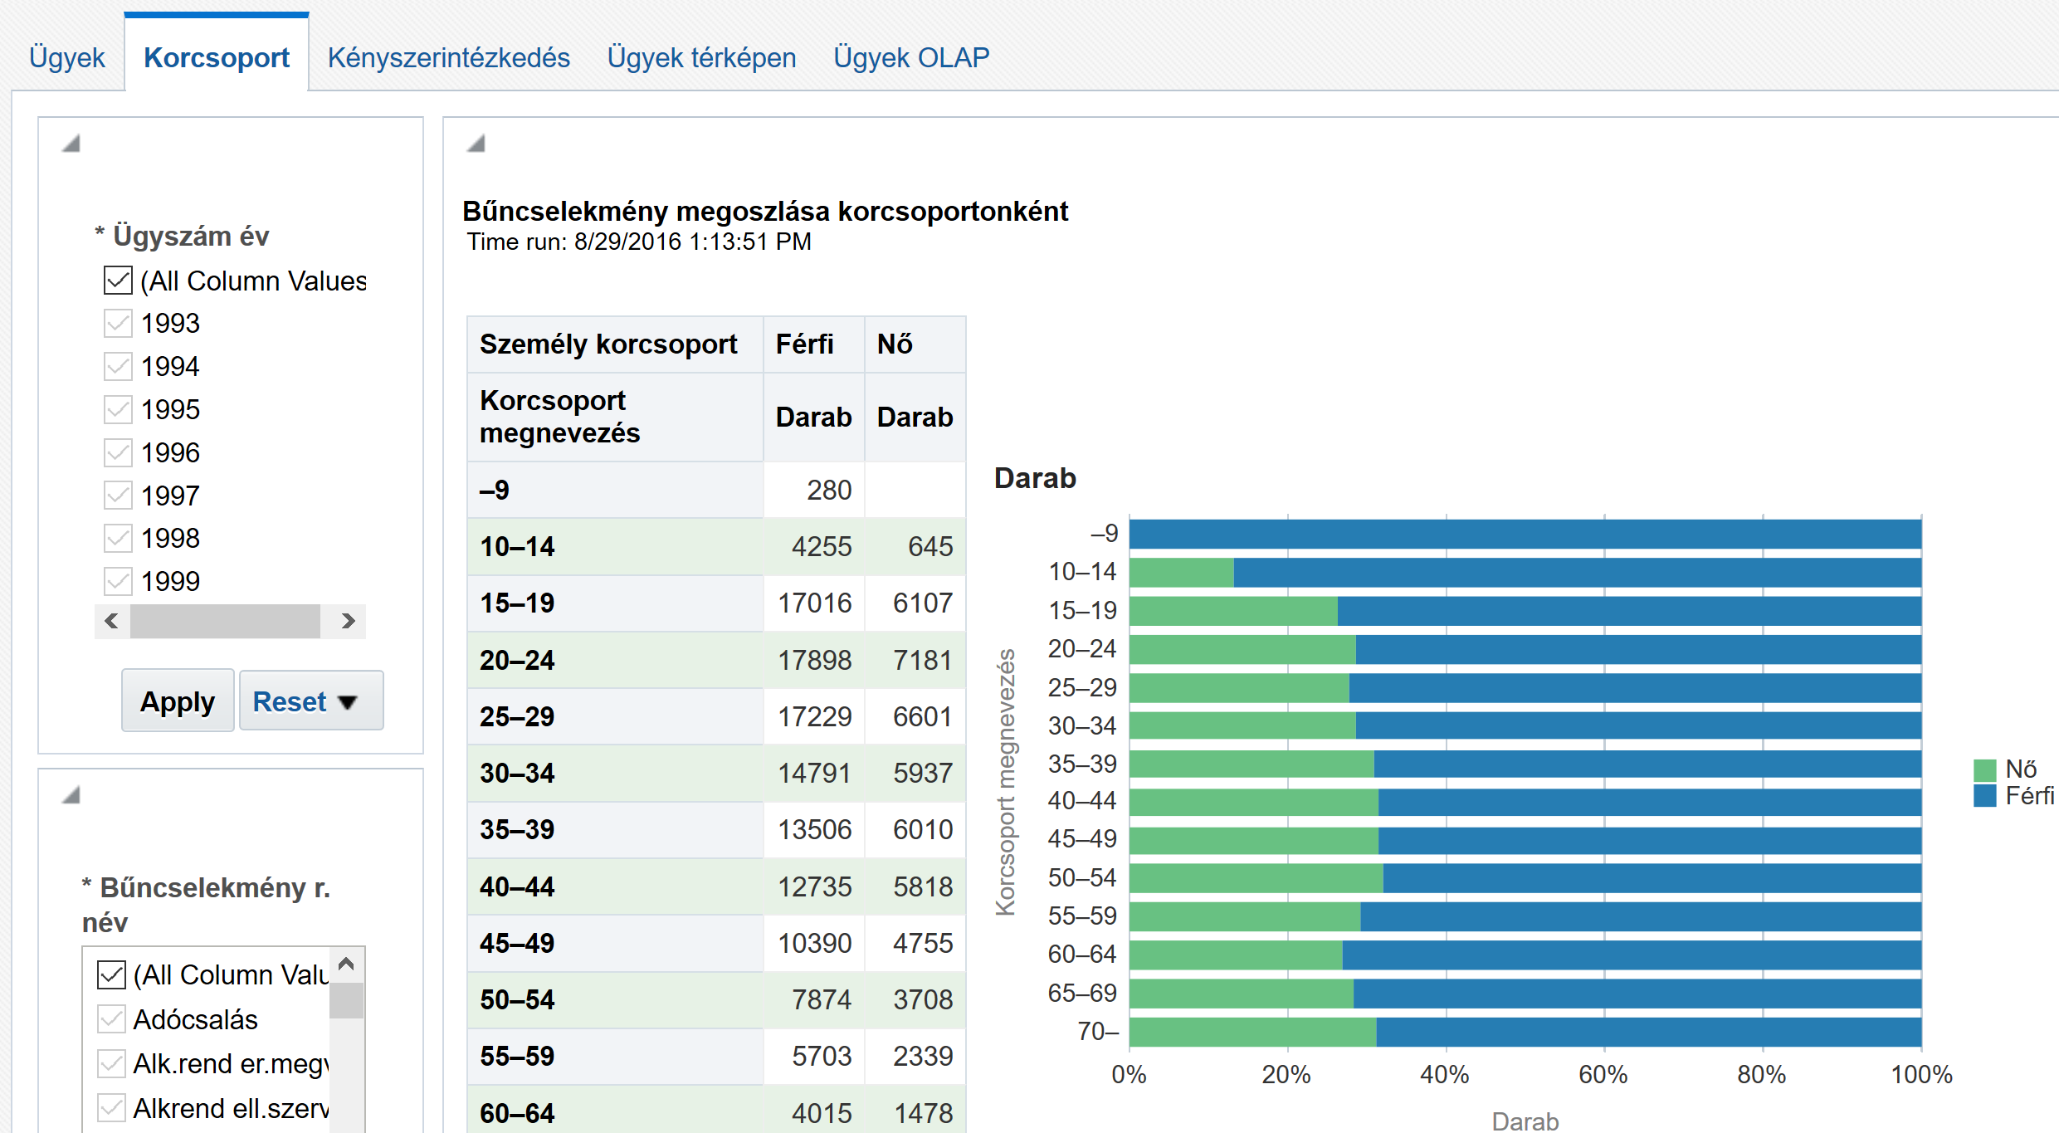

12. Distribution of criminal cases

#### Criminal cases on map

This analysis shows the number of criminal cases on a map. The map shows the counties administrative areas of Hungary. The bar graph show the number of persons involved in cases, grouped by gender. The bubble chart shows the number of cases in the corresponding county. The colour fill of counties shows the less and most (light to dark) affected counted by case numbers. The total number of cases was divided into 4 buckets using percentiles. White colour fill means there is no data.

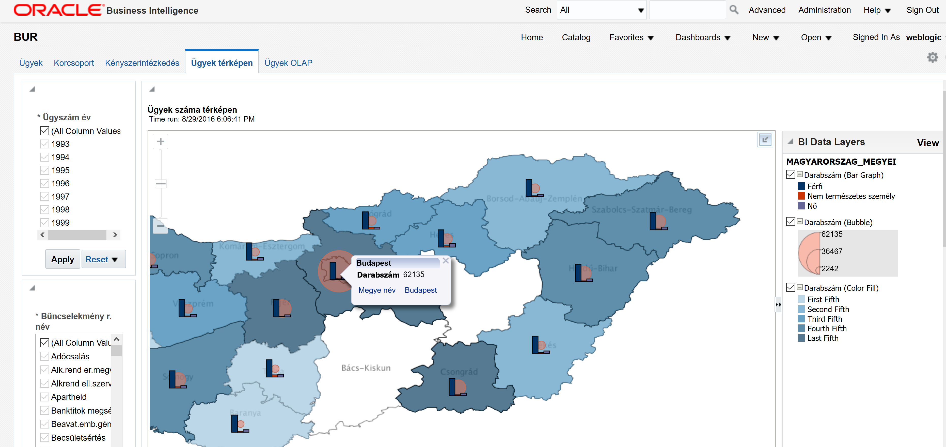

13. Criminal cases on map

#### Heat map

This analysis shows the data in a heat map. The matrix rows contains the counties, the matrix columns the years. In the cells are calculated the number of cases with grouping the data over counties and years. The total number of cases are divided into five buckets using percentiles: light colours means less cases, darker colours means more cases. Dashed cells means there is no data.

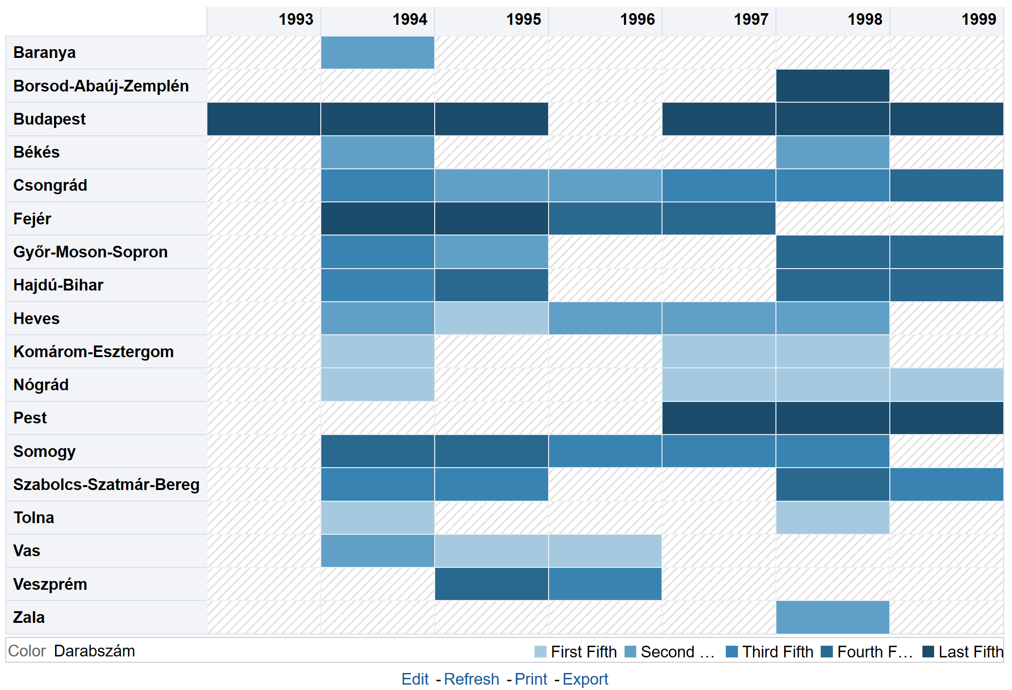

14. Heat map

#### Interactive charts

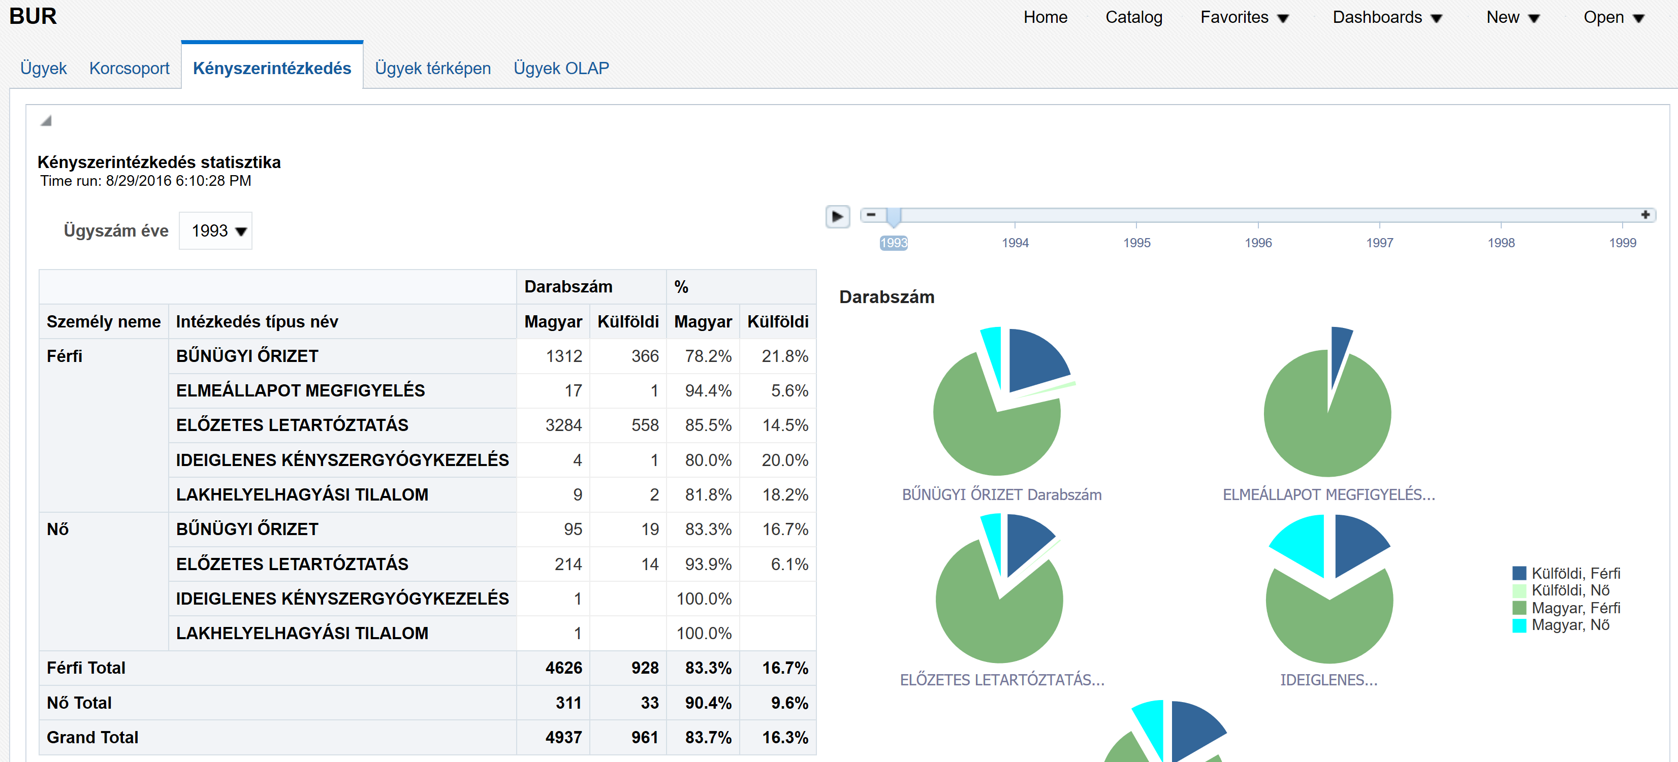

15. Interactive charts

## Oracle Rest Data Services

Oracle REST Data Services (ORDS) makes it easy to develop modern REST interfaces for relational data in the Oracle Database. ORDS is responsible to receive and translate the requests to APEX engine, and returns the results to the requester browser. ORDS is installed into Oracle Weblogic Server as a Java web application.

More detailed documentation can be accessed from [Oracle REST Data Services Documentation](http://docs.oracle.com/cd/E56351_01/index.htm) web page.

## Oracle Application Express

Oracle Application Express (APEX) is a declarative, web based developer tool, used for creating database centric applications. In EARK project APEX was used to build a simple, user friendly web application called Data Explorer, which helps the archivists, researchers and other consumers to access, query and visualize the data stored in a relational database.

More detailed documentation can be accessed from [Oracle Application Express Documentation](https://docs.oracle.com/cd/E59726_01/index.htm) web page.

### Data Explorer

The Data Explorer application is a web based application, powered by Oracle APEX engine. It is fully integrated with Oracle database. Data Explorer application key role is to enable customers to query relational data stored in an Oracle Database, without or minimal SQL knowledge. Also Data Explorer helps the data owner to manage access to the corresponding data.

With Data Explorer you can register data sources, typically database schemas, which holds DIP content extracted from long term archive repository. A DIP describes the structure of an archived relational database (tables, views, relations, metadata, etc.) and of course contains the archived data. Loading a DIP into an Oracle Database enables the Data Explorer to access the data stored in an archive. A data source can have many data sets. These data sets represents tables or views from the schema or custom queries. Data Explorer helps the data owner to create these data sets using wizards, also enables to manage the access privileges over these data sets. The data sets are used by consumers, when they are building custom reports.

Data Explorer main functions:

* register data sources
* add data sets (tables, views, custom queries)
* create interactive reports on data sets
* find relevant data by filtering column data
* aggregate data
* add custom calculations
* create charts
* export data

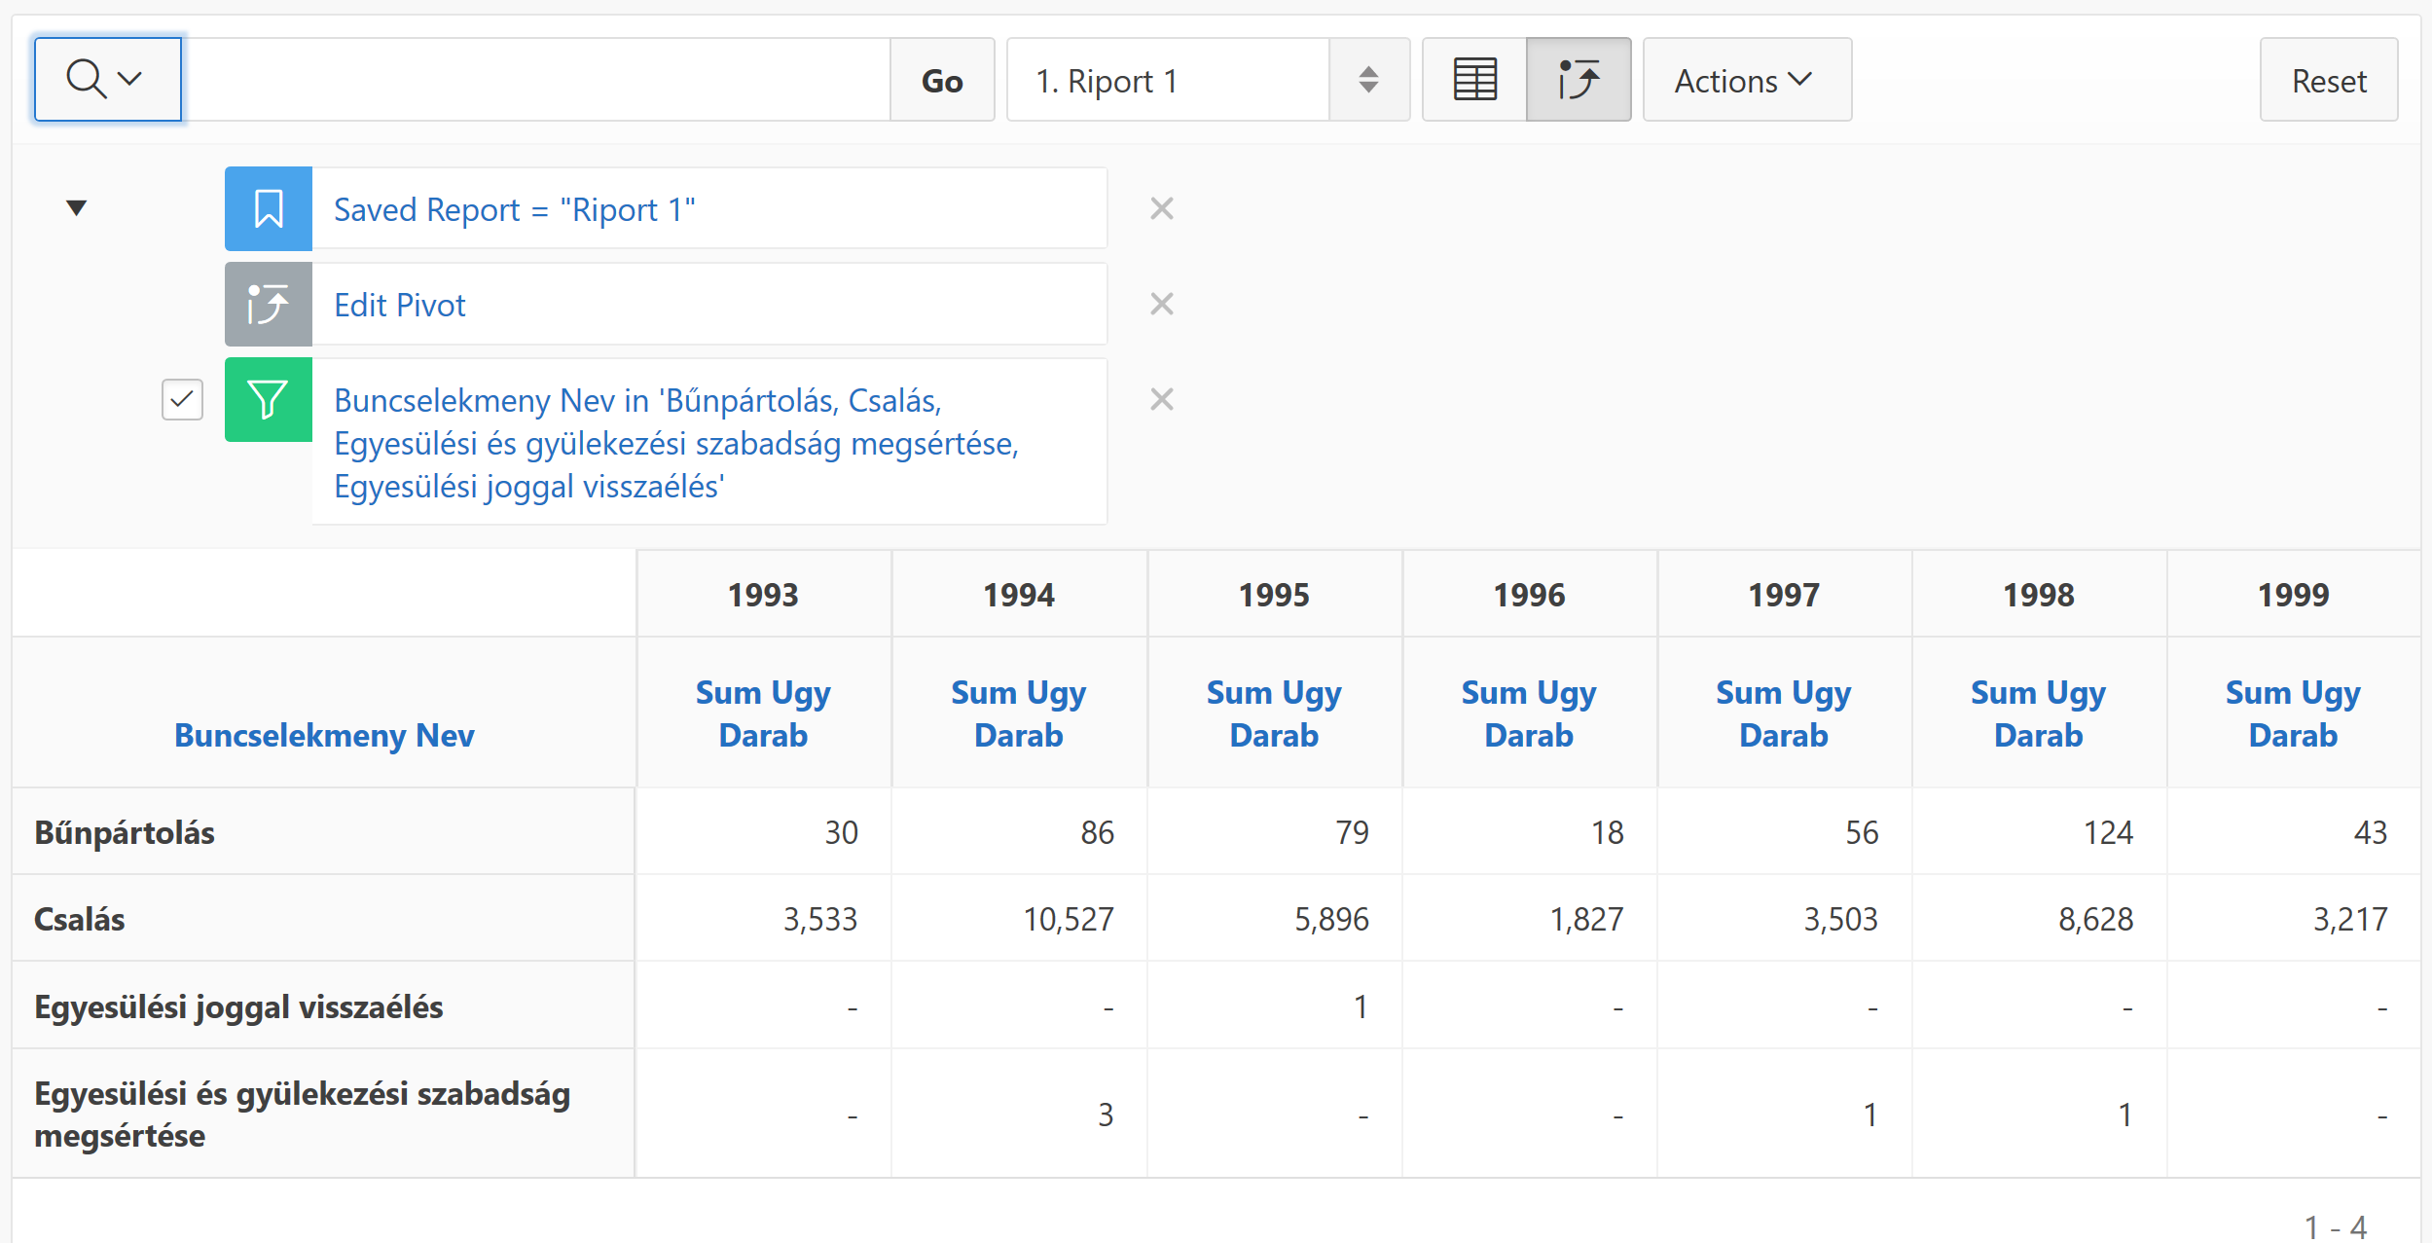

16. Data Explorer pivot report